BOOKING FORM FOR GROUP CLASSES
Name: | Partner’s name:
Address:

Telephone: Home: | Mobile:
Email: | Baby due:
How did you hear about us? If “internet”, what did you search for?

Please mark X next to the classes you would like to attend: (Z): run by Zana Parker (B): run by Barbara Wyant
Natural Pain Relief | X | Practical Birth Preparation | X
2017 |  | 2017
Fri 3 November (Z) |  | Sat 4 November (Z)
Fri 15 December (Z) |  | Sat 16 December (Z)
2018 |  | 2018
Fri 19 January (B) |  | Sat 20 January (B)
Fri 16 February (Z) |  | Sat 17 February (Z)
Sat 17 March (B) |  | Fri 23 March (B)
Sat 14 April (Z) |  | Sat 21 April (Z)
Sat 12 May (B) |  | Fri 18 May (B)
Fri 22 June (Z) |  | Sat 23 June (Z)
Fri 20 July (B) |  | Sat 21 July (B)

Our preferred method of payment is via electronic bank transfer and we can email you the details.

I would like to book the course on the dates above. I understand that the course fee is £248 for the full 2-day course (one date from each column) or £148 for just one day. I agree to make payment as soon as I receive payment details. I have read and accept the terms and conditions of the cancellation policy.

Signed ................................................................................................... Date ................................................

Please email or post your completed booking form to the practitioner running your course
Barbara Wyant, The Old Quarry, Doctors Hill, Sherfield English, Romsey, SO51 6JX (barbara4c@yahoo.com)
Zana Parker, 43 The Drive, Hounsdown, Southampton, SO40 9EP (info@BirthingWithConfidence.co.uk)
Please take time to read our Terms and Conditions, including our Cancellation Policy on page 3.

BOOKING FOR PRIVATE ONE-TO-ONE SESSION
Name: | Partner’s name:
Address:

Telephone: Home: | Mobile:
Email: | Baby due:
How did you hear about us? If “internet”, what did you search for?

Please discuss dates, times & venue with your chosen practitioner – Zana or Barbara - and then complete the details below. We can offer courses privately Monday to Friday, daytimes and/or evenings, depending on availability.
Class details
Natural Pain Relief  Date:  Time:  Booked with: Barbara / Zana  To be held at: | Practical Birth Preparation  Date:  Time:  Booked with: Barbara / Zana  To be held at:

Our preferred method of payment is via electronic bank transfer and we can email you the details.

I would like to book the 1-1 session(s) at the date and time above. I understand that the fee is £250 per day (either Natural Pain Relief or Practical Birth Preparation). I agree to make payment as soon as I receive bank transfer details. I have read and accept the terms and conditions of the cancellation policy.

Signed ................................................................................................... Date ............................................

Please email/post your completed booking form to the practitioner running your course:
Barbara Wyant, The Old Quarry, Doctors Hill, Sherfield English, Romsey, SO51 6JX (barbara4c@yahoo.com)
Zana Parker, 43 The Drive, Hounsdown, Southampton, SO40 9EP (zana.banana1@virginmedia.com)

Please take time to read our Terms and Conditions including our Cancellation Policy on page 3.

Terms and Conditions and Cancellation Policy for Natal Hypnotherapy Courses
Run By Licensed Practitioners Zana Parker and Barbara Wyant

The following terms and conditions are produced in accordance with guidance published by Natal Hypnotherapy.

A two-day Natal Hypnotherapy course costs £248 for a pregnant woman with/without her birth partner. (We are sorry but a pregnant friend counts as a separate attendee and she will need to book and pay in her own right.)

The cost for booking just one of the group dates is £148.

Private one-to-one courses are offered Monday to Friday subject to availability. A private course provided on a one-to-one basis costs £250 per day for a pregnant woman with/without her birth partner. If the day is held at the Client’s home travel up to 10 miles each way from the Practitioner’s home is included. If the journey to/from the Practitioner’s home to the Client’s home is over 10 miles each way the Practitioner will charge 45p per mile for the additional mileage over 10 miles each way. An alternative venue may be agreed between the Practitioner and the Clients. If the alternative venue for a one-to-one class incurs a hire charge this is payable in full by the Clients before the class takes place. If you and a pregnant friend, with birth partners, would like to take the course privately in one of your homes we are happy to offer a generous discount per couple on the private one-to-one day rate. Please enquire.

Course fees, along with any additional mileage charge and venue hire charge if applicable for 1-1 sessions, should be paid in full at time of booking please. If you need to spread the cost of the course and pay in two instalments please talk to us.

If a group or private course is booked and subsequently cancelled in writing or by email by the Client refunds will be supplied as follows:

42+ calendar days before the course begins: 75% refund
32-41 calendar days: 50%
22-31 calendar days: 25%
21 calendar days or less or “no show”: 0%

In the event of a very premature birth or personal tragedy requests for a refund will be considered on an individual basis. An administration charge may be made. If you book a course that starts within 3 weeks of your due date then no refunds will be made if your baby arrives before the course.

Group courses will be held at the New Forest Wellness Centre in Sherfield English. Your Practitioner will confirm venue details and send directions along with information about what to bring, etc, a few days prior to the course. Each day runs from 10am to 5.30/6pm. Your Practitioner will confirm times with you.

Your first downloadable track will be available as soon as the course fee has been paid in full so that you can experience the benefits straight away. Your course book and remaining 3 downloads will be available at your first session.

In the rare event of your Practitioner being taken ill or being otherwise unable to run your course we shall endeavour to work with you to find the best solution: alternative dates might be offered, or a replacement qualified and licensed Practitioner will be found, or you will receive a full refund.

Meet your local hypnobirthing practitioners!
You can read more about our qualifications and experience on our websites

Barbara has been practising as an NCT antenatal teacher since 2000 and is an experienced Natal Hypnotherapy hypnobirthing practitioner, qualified in the RCM accredited Hypnosis for Childbirth. She runs a homebirth group through social media and local meetings. Barbara is also a clinical hypnotherapist, a member of the General Hypnotherapy Register and registered with the CNHC. She uses hypnotherapy and NLP techniques to help clients overcome fears, anxieties and unwanted habits which may or may not relate to maternity, eg: fear of needles, anxiety about flying, quitting smoking, etc. Barbara has a background in midwifery and is keen to promote the benefits of hypnotherapy for health professionals themselves as well as the women in their care.

www.RomseyRelax.com
Barbara4c@yahoo.com
0794 86 86 891
www.facebook.com/RomseyRelax
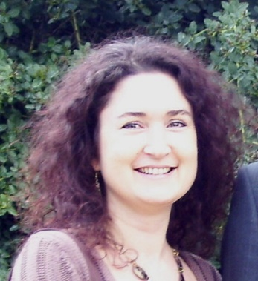
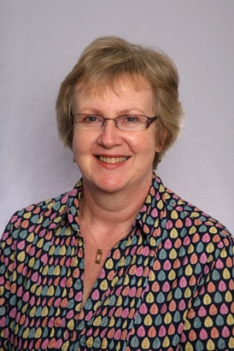
www.BirthingWithConfidence.co.uk
www.RomseyRelax.com

Zana has 20 years’ experience as a professionally qualified birth education expert. She is an experienced Natal Hypnotherapy hypnobirthing practitioner, qualified in the RCM accredited Hypnosis for Childbirth. She is also an NCT “Excellent Practitioner” Antenatal Teacher and a qualified and accredited Counsellor working in private practice. She has provided training for student midwives and hypnobirthing student practitioners. Zana is passionate about helping parents plan and prepare for the best possible birth experience, regardless of where and how their babies are born. She provides courses, classes and tailored services for groups, couples and individuals. In her counselling practice she works 1-1 with women and men, helping with a diverse range of issues and specialising in those relating to pregnancy, birth and parenting.

www.BirthingWithConfidence.co.uk
www.CounsellingWithZana.co.uk
info@birthingwithconfidence.co.uk
07905 658 386
www.facebook.com/BirthingConfidence

